SIX WEEKS SUMMER TRAINING REPORT

(Training Term June - July 2023)

### Java and Data Structures & Algorithm Program/BankXpert

Submitted by

### Name: Satwik Uppada Registration Number: 12111298

### Program Name: Java and Data Structures & Algorithm Program

**Course Code: CSE 443**

Under the Guidance of

### SHIRAJ SIR (Cipher Schools)

**School of Computer Science and Engineering**

**Lovely Professional University, Phagwara.**



Annexure-III

**DECLARATION**

I hereby declare that I have completed my six weeks summer training at “Cipher Schools” (name and location of organization) from June 15 (start date) to July 20(end date) under the guidance of shiraj sir (Name of Industry coordinator). I have declared that I have worked with full dedication during these six weeks of training and my learning outcomes fulfill the requirements of training for the award of degree of Java and Data Structures & Algorithm Program (Relevant Degree), Lovely Professional University, Phagwara

**(Signature of student)** 

**Name of Student**: Satwik Uppada

**Registration no**: 12111298

Date: 15/08/2023

**Acknowledgement**

I would like to extend my sincere appreciation to Cipher School for offering a self-paced learning opportunity through the six-week summer training program on "Java and Data Structures & Algorithm Programming." This distinctive mode of learning, based on recorded videos, has been an enriching experience that allowed me to learn at my own pace.

I would like to express my heartfelt gratitude to our instructor, Mr. Shiraj, whose well-structured video content and comprehensive explanations made the learning process engaging and effective. Despite the lack of direct interactions, his expertise and dedication shone through, providing me with a strong foundation in the subject matter.

I am also grateful for the support channels provided, including the WhatsApp and Telegram groups, as well as the weekend doubt sessions. These avenues played a crucial role in addressing my queries and concerns, fostering a sense of community among the participants.

I would like to thank my family and friends for their encouragement and understanding during this period of self-guided learning.

In conclusion, I am thankful to Cipher School for the unique learning experience and the valuable knowledge I have gained in Java, Data Structures, and Algorithms. This self-paced approach, supplemented by supportive platforms, has undoubtedly enhanced my skills and will contribute to my academic and professional growth.

Thank you.

Satwik Uppada

**CERTIFICATE**

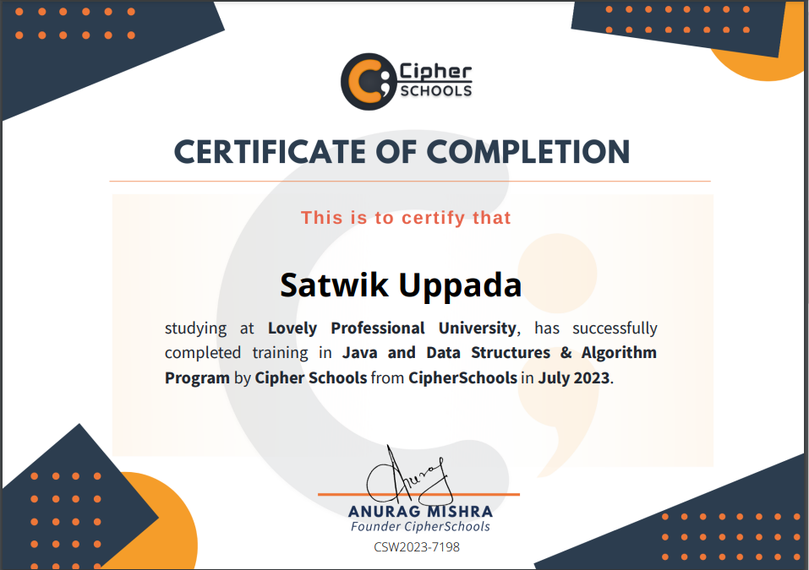

Signature and Name of the Mentor: Shiraj Sir

Designation: Teaching Assistant

Cipher Schools

Date: 25/07/2023(certificate issued date)

**INTRODUCTION**

*The project titled 'BankXpert' aims to develop a Java-based application that serves as a skeleton for a real-time banking system to simulate the core functionalities of a banking system.*

*It provides users with the ability to create customer accounts, perform transactions such as deposits, withdrawals, and transfers, and offers features like balance checking and transaction history. This project was undertaken as a part of my summer training program in which I focused on learning and implementing various concepts related to Data Structures and Algorithms (DSA) in Java. By developing 'BankXpert,' I aimed to apply the knowledge acquired during the training to create a functional and efficient banking simulation."*

***Motivation and Inspiration:***

*The motivation behind undertaking the 'BankXpert' project was significantly influenced by the innovative payment system known as UPI 123Pay. This cutting-edge technology, witnessed in devices like the Nokia 105 keypad phone, presented a remarkable solution to enable digital transactions even in the absence of an internet connection. The sight of an inbuilt UPI app within a basic keypad mobile left a profound impact on my perspective about the possibilities of technology integration.*

*The emergence of UPI 123Pay showcased the potential to bridge the digital divide and bring financial inclusivity to a vast population, particularly those who rely on feature phones in areas with limited internet access*

*This concept of enabling secure and convenient transactions on non-smartphone devices resonated deeply with me and ignited my curiosity to explore how such advancements could be practically implemented.*

*The UPI 123Pay innovation served as a spark that inspired me to embark on the journey of developing 'BankXpert.' Witnessing the seamless integration of technology into daily life, especially in contexts where internet connectivity is a challenge, reinforced my belief that software applications can drive transformative changes across diverse user segments. The realization that technology can break barriers and offer solutions accessible to everyone, regardless of their device's capabilities, was a driving force behind my decision to create an application that emulates certain features of a real-time banking system.*

*By channeling this motivation into the development of 'BankXpert,' I aimed to contribute to the ongoing evolution of technology-driven financial services. This project represents an effort to capture the essence of convenience and accessibility showcased by UPI 123Pay and apply it to a broader context through a functional and educational banking simulation. The result is a practical application that stands as a testament to the potential of technology to empower individuals and communities, regardless of the tools they have at their disposal.*

**TECHNOLOGY LEARNING**

*During my summer training program, I immersed myself in learning essential concepts related to Data Structures and Algorithms (DSA) in Java. This comprehensive training laid the foundation for my ability to design and implement efficient solutions to complex problems. As I delved deeper into the world of Java programming, I recognized the immense potential of applying these skills to create practical applications that could have a real-world impact.*

**CHOOS**I**NG THE PROJECT: BRIDGING THE GAP**

*The inspiration for the 'BankXpert' project came from observing the UPI 123 service available on Nokia's new 105 keypad mobile phones. Witnessing the convenience and inclusivity this technology offered, I saw an opportunity to bridge the gap between advanced mobile banking and feature phone users. The idea of developing a Java-based application that simulates the core functionalities of a real-time banking system became a natural progression of this vision*

**PROFILE OF THE PROBLEM**

*Modern banking systems are heavily reliant on digital platforms, often leaving feature phone users without access to essential financial services. In many parts of the world, especially rural areas, feature phones are still prevalent due to their affordability and durability. However, these users often face challenges in accessing banking services and performing digital transactions. 'BankXpert' aims to address this disparity by providing feature phone users with a simplified banking experience that aligns with their technological constraints.*

**EXISTING SYSTEM**

*The existing banking applications are primarily tailored for smartphones and computers, offering a wide array of features that are often not accessible to feature phone users. While these applications are comprehensive and user-friendly, they leave a significant portion of the population underserved. 'BankXpert' seeks to streamline the banking process for feature phone users while incorporating some innovative features to enhance user experience and security.*

**PROBLEM ANALYSIS**

***Problem Definition:*** *The problem at hand is the lack of an inclusive and simplified banking application for feature phone users. Many individuals in remote and rural areas rely on feature phones, and providing them with a secure and accessible way to perform essential banking transactions is crucial.*

***Feasibility Analysis:*** *Considering the prevalence of feature phones and the success of UPI 123-like services, the feasibility of 'BankXpert' is evident. The project aligns with the ongoing digitalization efforts and the push for financial inclusion.*

**SOFTWARE** **REQUIREMENT ANALYSIS**

*In the software requirement analysis phase, the focus was on defining the functional and non-functional requirements of the 'BankXpert' project. These requirements form the foundation for designing and developing the application. Some of the key software requirements identified include:*

***Functional Requirements:***

* *User Registration and Account Creation*
* *Deposit, Withdrawal, and Transfer Operations*
* *Balance Checking*
* *Transaction History*
* *Reminder Mechanisms for Minimum Balance*
* *Security Measures (e.g., Password Protection)*

1. **User Registration:** The application shall allow users to register by providing their personal information such as name, age, city, date of birth, mobile number, and identification details (PAN/Driving License/Aadhar).
2. **Account Creation:** Users shall have the option to create either a Current Account or a Savings Account. The system shall generate unique account numbers and passwords for each account.
3. **Transaction Operations:** Users shall be able to perform deposit, withdrawal, and transfer transactions using their accounts. The system shall validate the transaction requests and update account balances accordingly.
4. **Balance Checking:** The application shall display the current account balance before the user proceeds with any account manipulation operation.
5. **Reminder Mechanisms:** The system shall provide reminders to users in specific scenarios, such as when the account balance is below the minimum required amount, or when performing whole amount withdrawals or transfers.
6. **Security Measures:** The application shall generate strong and secure passwords for accounts. It shall also validate user input to prevent unauthorized access and ensure data integrity

***Non-Functional Requirements:***

* *User-Friendly Interface*
* *Performance*
* *Reliability and Data Integrity*
* *Security*
* *Scalability*

1. **Performance:** The application shall handle a significant number of user accounts and transactions efficiently without noticeable delays.
2. **User Interface:** While the application primarily operates via the command-line interface, it shall provide clear and user-friendly prompts for input and interactions.
3. **Security:** User information and account data shall be stored securely. While the current implementation of the project does not include encryption techniques for password storage, the project shall take measures to enhance security in future iterations.
4. **Reliability:** The application shall ensure accurate transaction handling and proper balance updates, maintaining the integrity of user accounts and data.
5. **Scalability:** The application architecture shall be designed to accommodate potential future enhancements and new features without significant modifications.

**DESIGN**

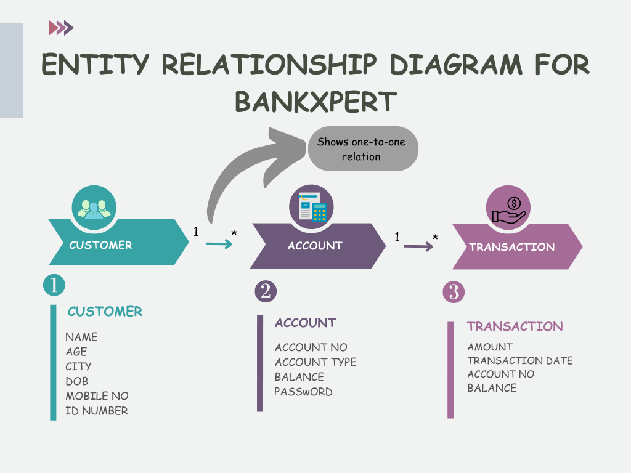

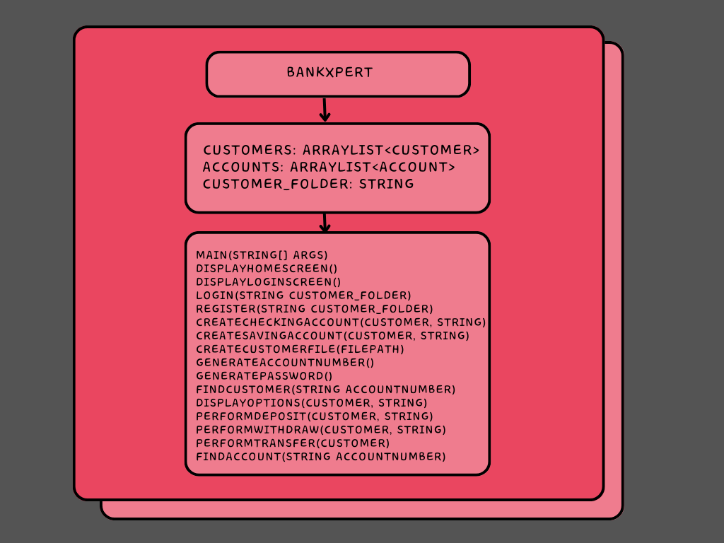**STRUCTURAL FRAMEWORK FOR THE BANKXPERT**

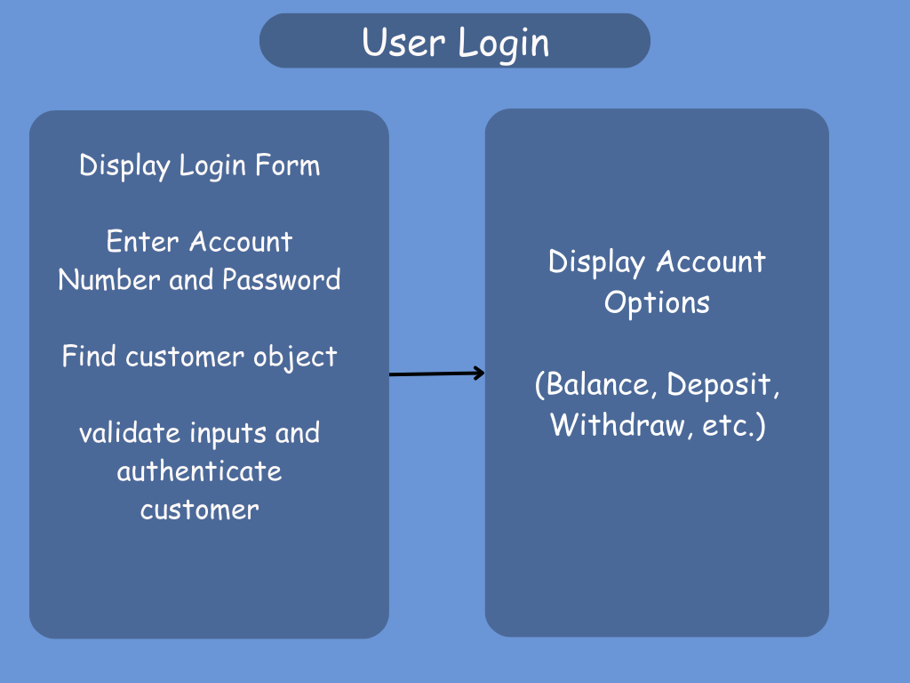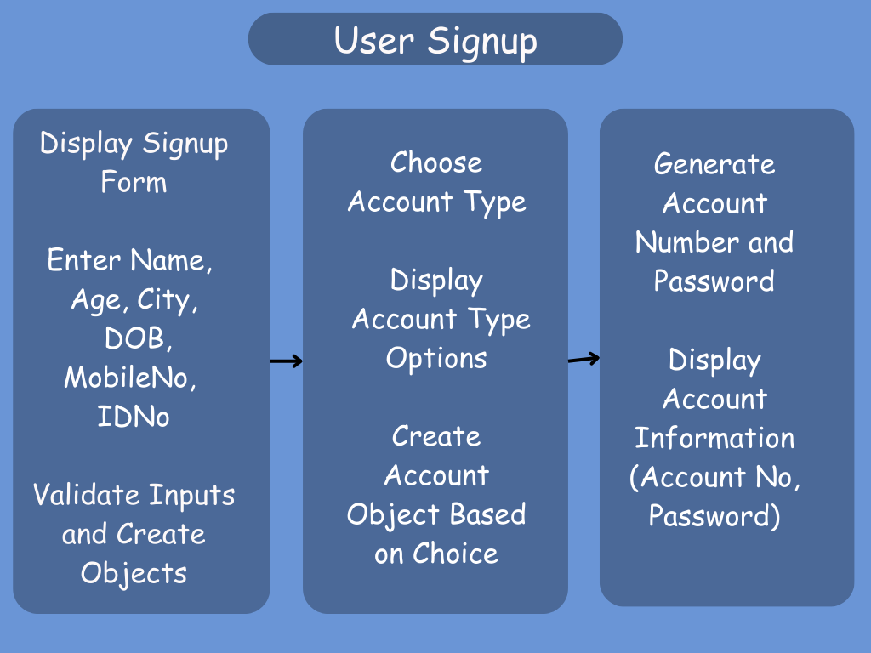

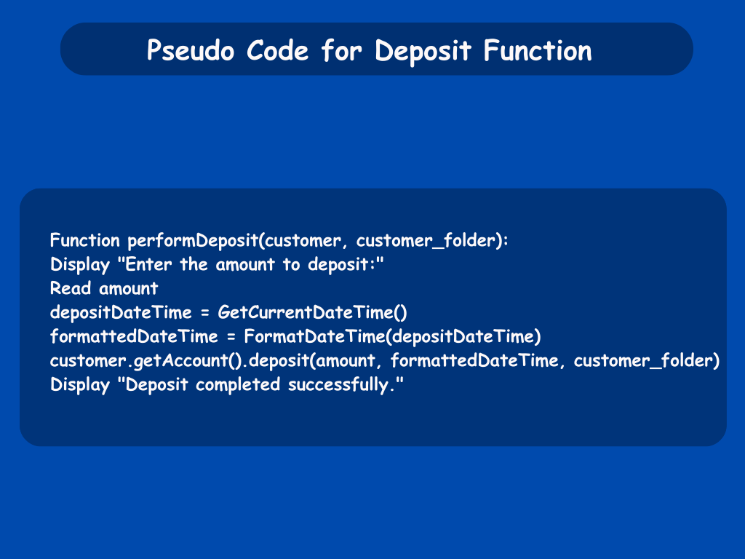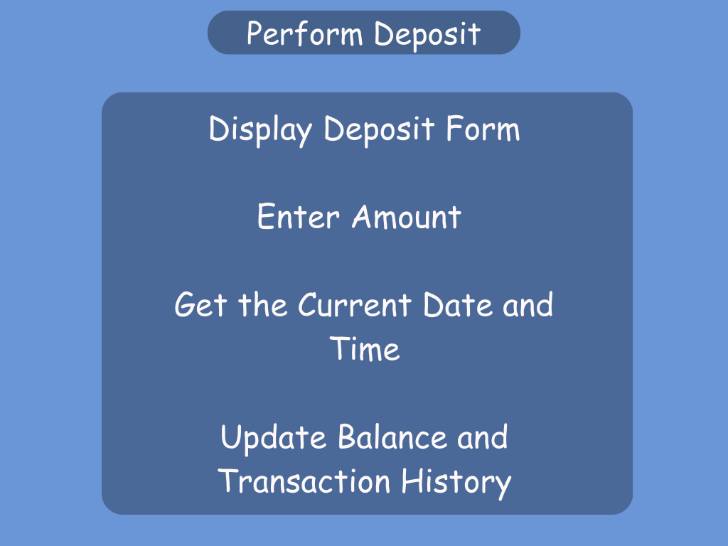

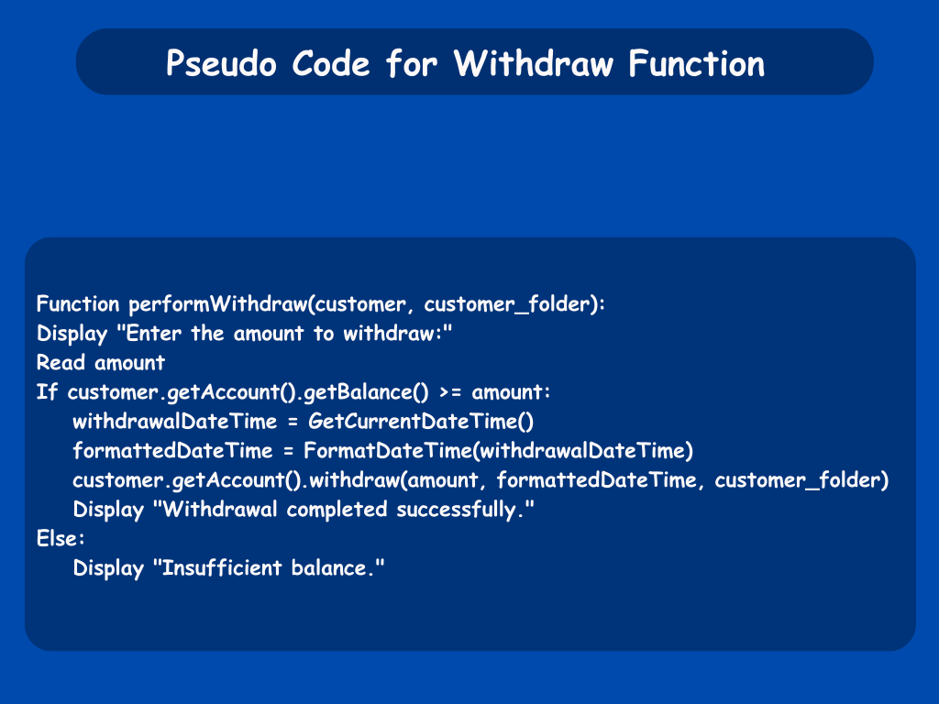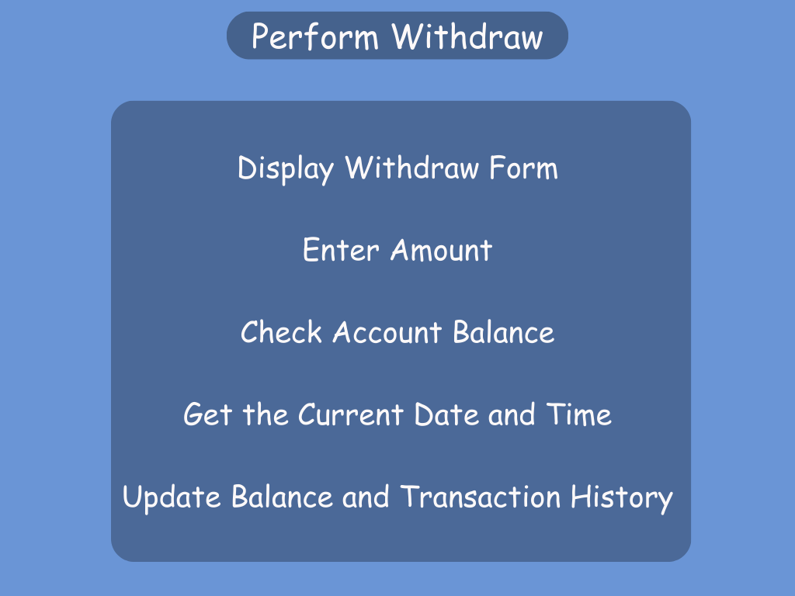

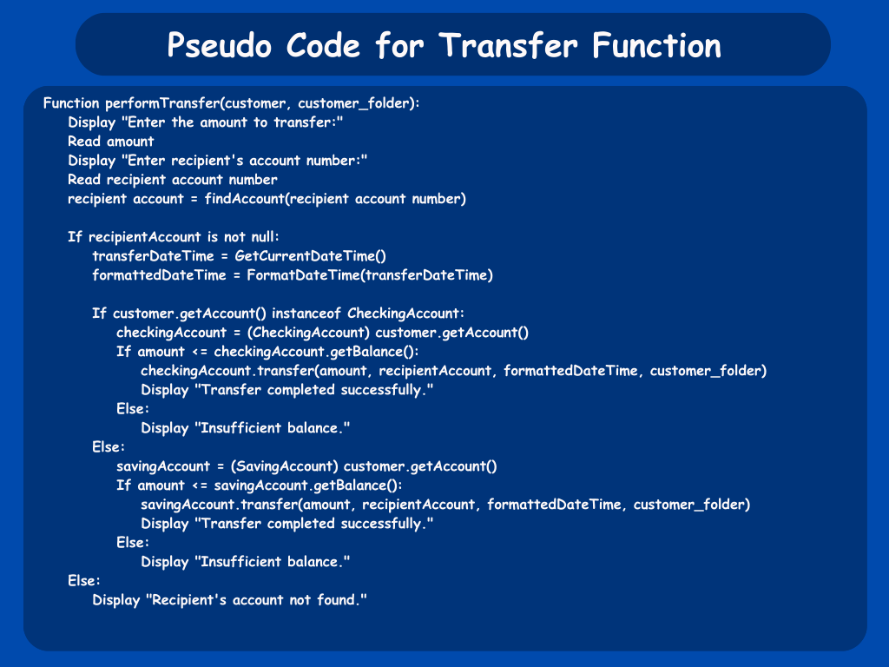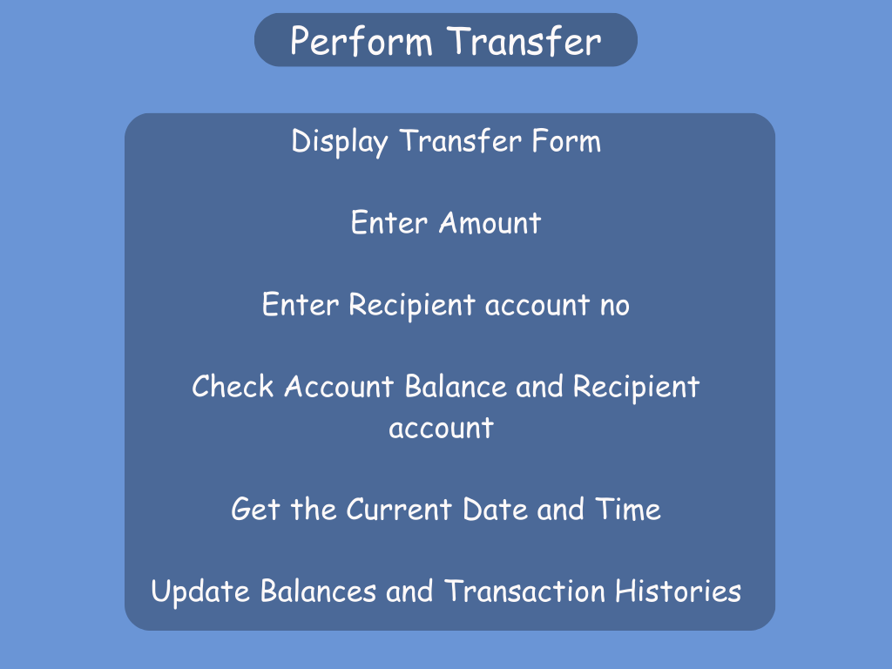

**IMPLEMENTATION**

Link: <https://github.com/Satwik-uppada/BankXpert.git>

Images: click to view

**LEARNING OUTCOMES**

* Java Programming Proficiency: Through the development of the BankXpert application, I gained a solid understanding of Java programming concepts, including data types, control structures, object-oriented principles, and file handling.
* Application Development: Developing BankXpert provided hands-on experience in designing and building a complete software application from scratch. This included understanding user requirements, designing the application architecture, implementing core functionalities, and ensuring a user-friendly interface.
* Data Structure Utilization: I learned how to effectively use data structures like ArrayLists to manage and manipulate collections of data, enhancing the application's efficiency and readability.
* Algorithm Implementation: The project allowed me to implement various algorithms for functions like deposit, withdrawal, and transfer. This improved my algorithmic thinking and problem-solving skills.
* Software Design Principles: By creating flowcharts and pseudo code, I learned how to plan the logical flow of an application before actual implementation. This enhanced my ability to design efficient and well-organized software
* User Interaction Handling: Designing the user interface for BankXpert taught me how to handle user interactions through the console, improving my skills in input validation and providing user-friendly feedback.
* Security Considerations: I gained insights into security considerations like password encryption for user account protection, which is a critical aspect of real-world applications.
* Time Management: Creating BankXpert within a specific timeframe improved my project management and time management skills, helping me to set milestones and track progress effectively.
* Documentation Skills: Writing the project report required clear and concise documentation of the project's various phases, enhancing my ability to communicate technical concepts effectively.

**CONCLUSION**

The creation of 'BankXpert' has been a valuable journey that has enhanced my Java programming and data structure skills. The project's implementation of core banking functionalities, combined with the use of data structures like ArrayLists, has provided a solid foundation for a real-time banking application. This experience has not only deepened my technical understanding but has also reinforced the importance of problem-solving, logical thinking, and effective project management. As I look ahead, the lessons learned from 'BankXpert' will undoubtedly shape my future endeavors in software development.